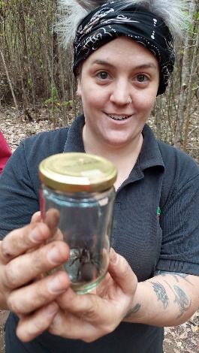
2 February 2024

Report by Dr Cass Lynch

Kaya walbungkara/trapdoor spider volunteers

A BIG thank you to everyone who came down and helped out at Operation Spider Rescue January 27 and 28 at the Tree-in-the-Rock Day Use Area in the Porongurup National Park.

With your help we relocated 34 walbungkara/trapdoor spiders, adding to the 6 we had relocated as part of the pilot study.
That's 40 spiders in total rescued and relocated since we started this project last May. I said a prayer for the spiders we couldn't bring up, and I hope they find a way to escape the shovels and bitumen that have come their way this week.

The relocation site includes 37 spiders of at least two species, dwelling within the site; (the other three are outside the relocation zone). During the dig we noticed how different some of the Proshies looked from one another; we will study the photos and work out whether there is a third species present. A big surprise from the weekend!
We are planning to monitor the relocation site to see how the spiders go. The first 6 in the pilot study managed to dig new burrows; we have high hopes.

I'm happy and exhausted and indebted to Leanda and Loxley and all of you. We will have more information, videos, and photos to share in the future. We are making an archive of photos and videos from the weekend, so if you have any media you'd like to contribute please feel free to send it through to me. Josephine Hayes ,Gondwana Link filmed us so there may be a short video about the rescue later in the year.
If you have any thoughts or feedback please send that through too!

Thank you again for bringing such good energy to the rescue effort. I think we've built a solid foundation for walbungkara advocacy in the Porongurup moving forward.

Cheers! Dr Cass Lynch
PhD, BA (Hons), BA (Media Studies)
Post-Doctoral Research Fellow | School of Media, Creative Arts and Social Inquiry
Curtin University
Room | 209:308
Tel | 08 9266 7031
Email | cassie.lynch@curtin.edu.au
Web | curtin.edu.au
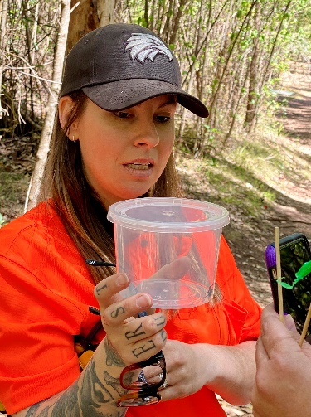

Thank you from Leanda Mason
“We were able to successfully relocate 40 spiders outside the impacted zone.”

Today marks the end of a project Cass Lynch, Loxley Fedec and I started in April 2023 to try save some trapdoor spiders from being cemented over in the Porongurup at Tree-in-the-Rock.
The construction of the pathway would have potentially impacted large populations of Cataxia bolganupensis (first described by Barbara York Main in 1985), Proshermacha and what I think may be Stanwellia that have accumulated along the Tree-in-the- Rock pathway.
After some preliminary basic ecology research completed early in the project, we concluded this very high accumulation of spiders may be due to preferences in species for a certain depth of leaf litter that is maintained by the path. Some trials of non-invasive burrow traps designed by Cameron Blackburn were trialled, but while highly successful in other projects, did not work for these species.
While we tried our best to relocate by digging up as many spiders as possible this last weekend with incredible effort and the support of local community members, there will still be some spider that we were unable to rescue.
Although the translocation site is still within the reserve and only 50m away, the timing is not ideal and we will continue to monitor their survival.
Some of the spiders produced spiderlings, which we will rear in captivity and re-release back to their boodja in the future.
I am so deeply grateful, thankful and inspired by all those involved in this project - it was a true honour and privilege. Leanda Mason 

Community, conservation, culture and science
all working together as it should be.
by Loxley Fedec
The Spider Rescue project was a wonderful success with 45 spiders successfully extracted and relocated, enough for a viable new colony (or 2 - with two species involved).
I have posted on Facebook trying to balance appreciation without saying where exactly, what species exactly, and not being critical of DBCA. The project could not have proceeded had DBCA not given permission and Cass & Leanda want that acknowledged.

It was always DBCA’s responsibility but Cass and Leanda hope to build a relationship with them and hope that the success of this project with build credibility and trust for the future. I agree.

FB: I was so privileged over the weekend to participate in an amazing project with two inspiring young Noongar people relocating some Trapdoor Spiders that were about to be impacted.

Thank you Dr Cass Lynch & Dr Leanda Mason for leading us and teaching us many lessons in culture, determination and grace.

Thank you to the volunteers coming from as far away as Albany, Denmark and Kojonup for contributing your time and effort to this incredibly worthwhile project.

Thank you also to DBCA for trusting us and enabling the relocation to proceed. I hope this can lead to similar collaborative projects in the future. Just so empowering on so many levels with a truly positive outcome.

22 volunteers joined us plus Cass & Leanda. Here we are celebrating a “fantastic” effort to save short-range trapdoor spiders from a carpark upgrade saw 45 arachnids carefully moved from their homes in the Porongurups.
